**TASK 1:**

1. Installed the mysql container image from Docker hub on Docker desktop.
2. Connected to the virtual database using the connection details provided:

**SQL Link:**

DB Name: **project_medical_data_history**

Host: ###########

Domain Name: projects.datamites.com

Username: **dm_team4**

Password: **################**

1. show databases;

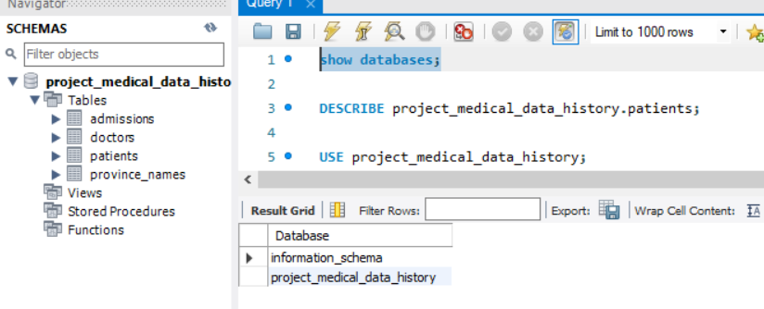

1. Got the schema for “patients” table using the **DESCRIBE project_medical_data_history.patients;** command.

|  |  |  |  |  |  |
| --- | --- | --- | --- | --- | --- |
| **Field** | **Type** | **Null** | **Key** | **Default** | **Extra** |
| patient_id | int(11) | NO | PRI |  |  |
| first_name | varchar(150) | YES |  |  |  |
| last_name | varchar(150) | YES |  |  |  |
| gender | char(1) | YES |  |  |  |
| birth_date | date | YES |  |  |  |
| city | varchar(150) | YES |  |  |  |
| province_id | char(2) | YES |  |  |  |
| allergies | varchar(150) | YES |  |  |  |
| height | decimal(3,0) | YES |  |  |  |
| weight | decimal(4,0) | YES |  |  |  |

1. SELECT * FROM patients;

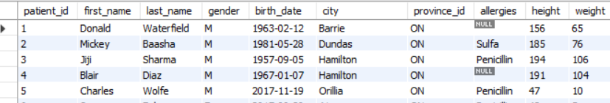

**TASK 2:**

*Complete query outputs are in attached excel sheet.

1. **Show first name, last name, and gender of patients whose gender is 'M'**

**Ans.** SELECT first_name, last_name, gender FROM patients WHERE gender = 'M';

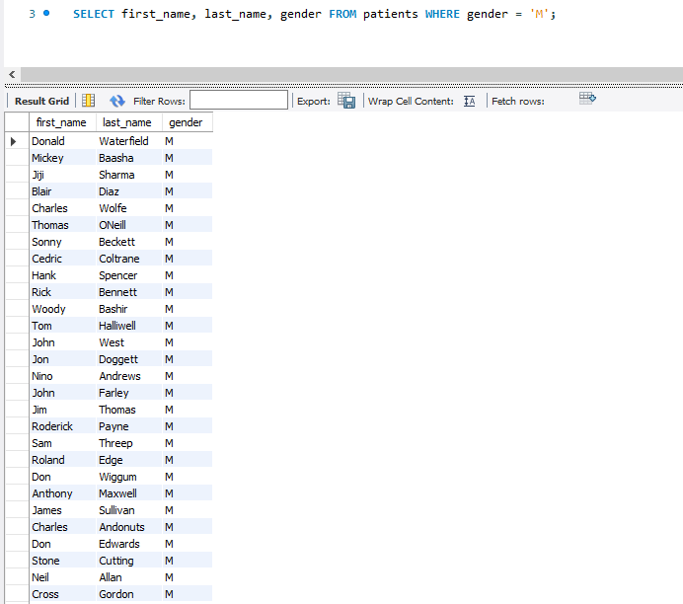

1. **Show first name and last name of patients who do not have allergies.**

Ans. SELECT first_name, last_name FROM patients WHERE allergies IS NULL;

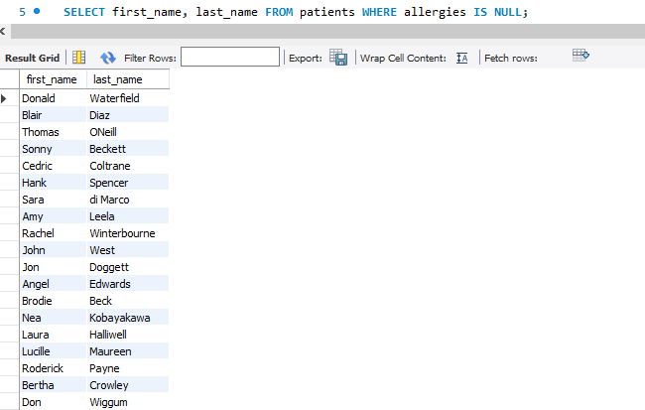

1. **Show first name of patients that start with the letter 'C'.**

**Ans.** SELECT first_name FROM patients WHERE first_name LIKE 'C%';

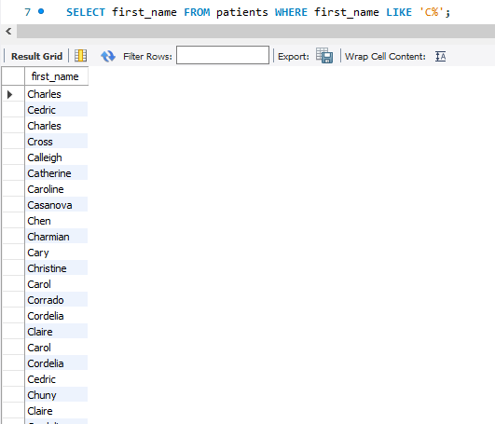

1. **Show first name and last name of patients that weight within the range of**

**100 to 120 (inclusive)**

**Ans.** SELECT first_name, last_name FROM patients WHERE weight BETWEEN 100 AND 120;



1. **Update the patients table for the allergies column. If the patient's allergies is**

**null then replace it with 'NKA'**

**Ans.** UPDATE patients SET allergies = 'NKA' WHERE allergies IS NULL;

**UPDATE patients SET allergies = 'NKA' WHERE allergies IS NULL Error Code: 1142. UPDATE command denied to user 'dm_team4'@'106.219.156.221' for table 'patients'**

Need to check with the team if this user has update rights to this database.

1. **Show first name and last name concatenated into one column to show their**

**full name.**

**Ans.** SELECT CONCAT(first_name," ", last_name) AS full_name FROM patients;

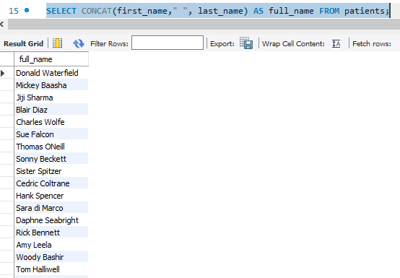

1. **Show first name, last name, and the full province name of each patient.**

**Ans.**  SELECT patients.first_name, patients.last_name, province_names.province_name FROM patients INNER JOIN province_names ON patients.province_id=province_names.province_id;

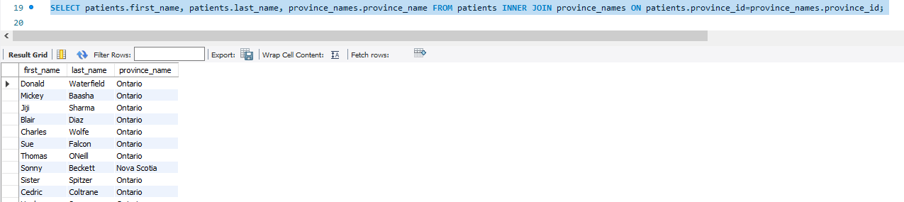

1. **Show how many patients have a birth_date with 2010 as the birth year.**

**Ans.** SELECT COUNT(patient_id) FROM patients WHERE YEAR(birth_date) = 2010;

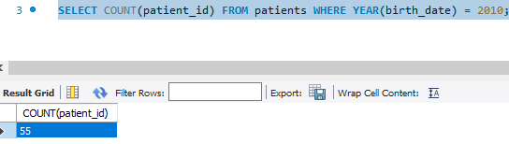

1. **Show the first_name, last_name, and height of the patient with the greatest**

**height.**

**Ans.** SELECT first_name, last_name, height from patients WHERE height = (SELECT MAX(height) FROM patients);

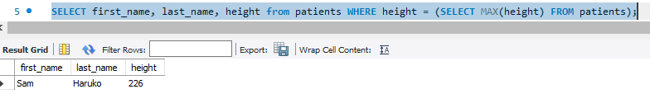

1. **Show all columns for patients who have one of the following patient_ids: 1,45,534,879,1000**

**Ans.** SELECT * FROM patients WHERE patient_id IN (1,45,534,879,1000)

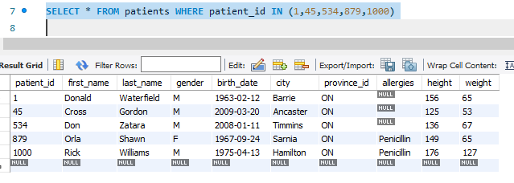

1. **Show the total number of admissions**

**Ans.** SELECT COUNT(patient_id) FROM admissions;

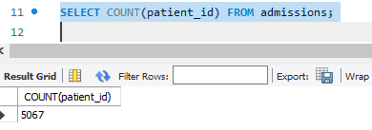

1. **Show all the columns from admissions where the patient was admitted**

**and discharged on the same day.**

**Ans.** SELECT * FROM admissions WHERE admission_date=discharge_date;

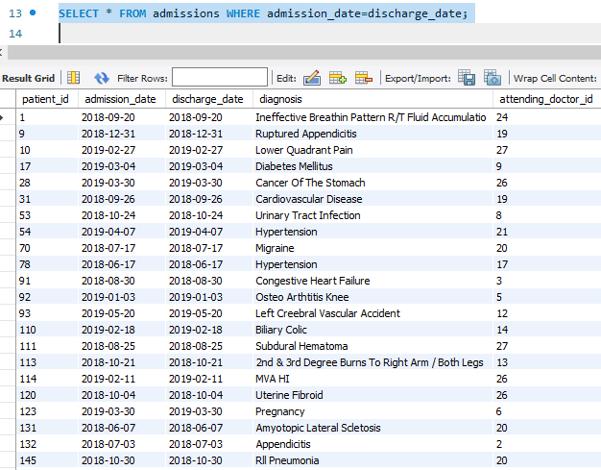

1. **Show the total number of admissions for patient_id 579.**

**Ans.** SELECT COUNT(*) FROM admissions WHERE patient_id=579;

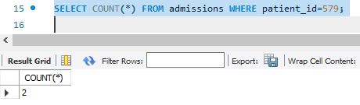

1. **Based on the cities that our patients live in, show unique cities that are in**

**province_id 'NS'?**

**Ans.** SELECT DISTINCT city FROM patients WHERE province_id='NS';

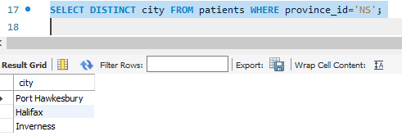

1. **Write a query to find the first_name, last name and birth date of patients**

**who have height more than 160 and weight more than 70.**

**Ans.** SELECT first_name, last_name, birth_date FROM patients WHERE height>160 AND weight>70;

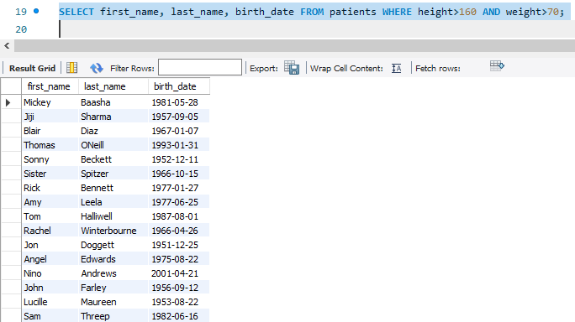

1. **Show unique birth years from patients and order them by ascending.**

**Ans.** SELECT DISTINCT YEAR(birth_date) FROM patients ORDER BY YEAR(birth_date);

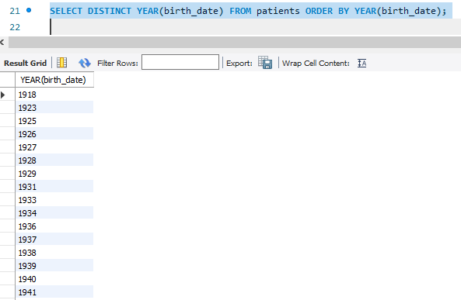

1. **Show unique first names from the patients table which only occurs once in**

**the list.**

**Ans.** SELECT DISTINCT first_name FROM patients;

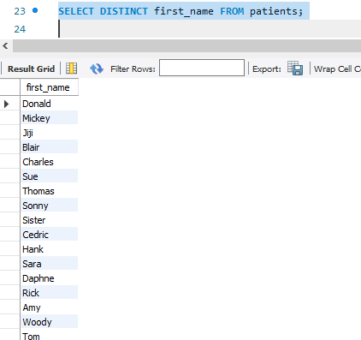

1. **Show patient_id and first_name from patients where their first_name starts**

**and ends with 's' and is at least 6 characters long.**

**Ans.** SELECT patient_id, first_name FROM patients WHERE first_name LIKE 's____%s';

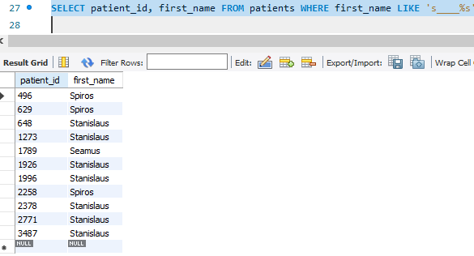

1. **Show patient_id, first_name, last_name from patients whose diagnosis is**

**'Dementia'. Primary diagnosis is stored in the admissions table.**

**Ans.** SELECT admissions.patient_id, patients.first_name, patients.last_name FROM patients INNER JOIN admissions ON patients.patient_id = admissions.patient_id WHERE diagnosis='Dementia';

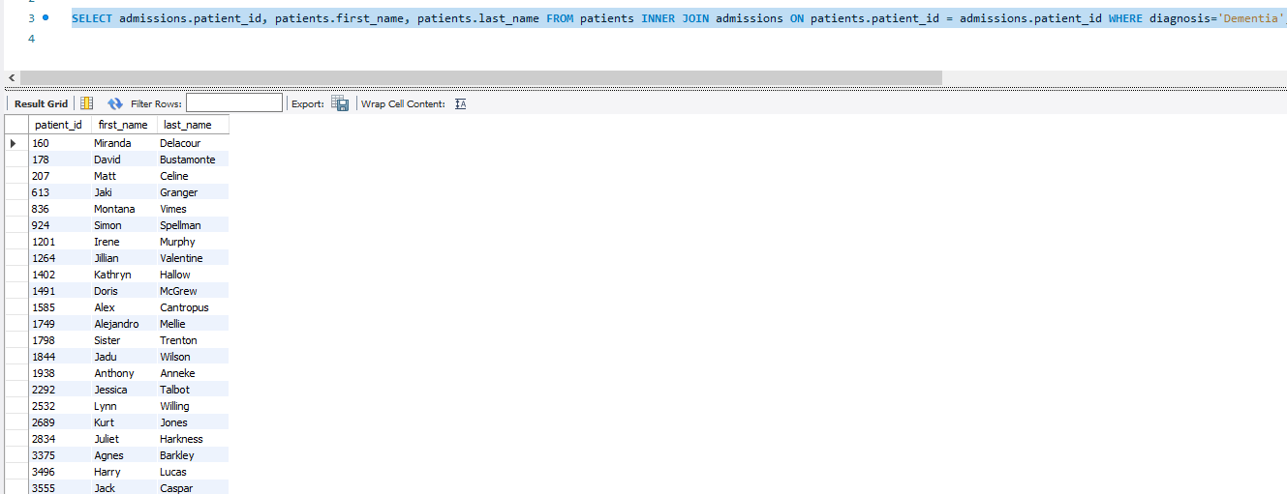

1. **Display every patient's first_name. Order the list by the length of each**

**name and then by alphabetically.**

**Ans.** SELECT first_name FROM patients ORDER BY LENGTH(first_name), first_name LIMIT 5000;

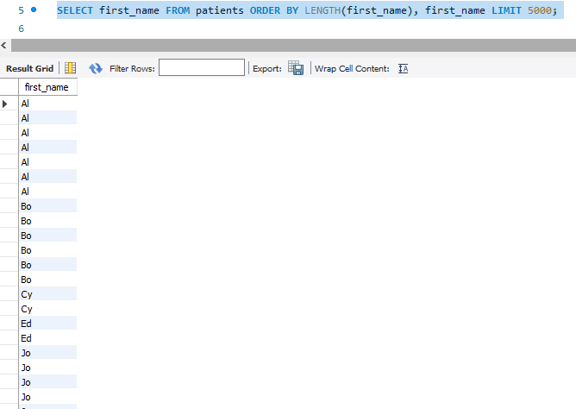

1. **Show the total number of male patients and the total number of female**
2. **patients in the patients table. Display the two results in the same row.**

**Ans.** SELECT (SELECT COUNT(first_name) FROM patients WHERE gender='M') AS MalePatients, (SELECT COUNT(first_name) FROM patients WHERE gender='F') AS FemalePatients;

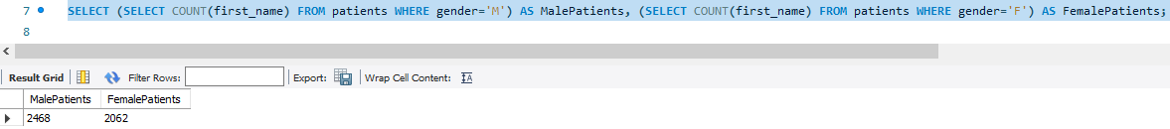

1. **Show patient_id, diagnosis from admissions. Find patients admitted**

**multiple times for the same diagnosis.**

**Ans.** SELECT patient_id, ANY_VALUE(diagnosis) FROM admissions GROUP BY patient_id, ANY_VALUE(diagnosis) HAVING COUNT(patient_id) > 1;

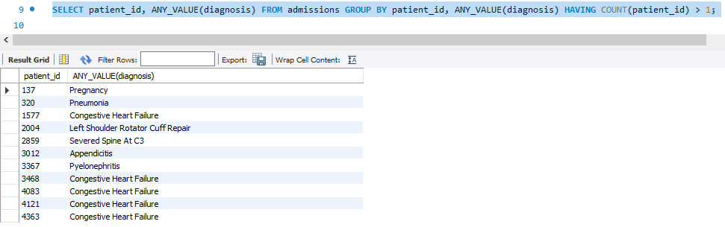

1. **Show the city and the total number of patients in the city. Order from most**

**to least patients and then by city name ascending.**

**Ans.** SELECT city, COUNT(first_name) FROM patients GROUP BY city ORDER BY COUNT(first_name) DESC, city ASC;

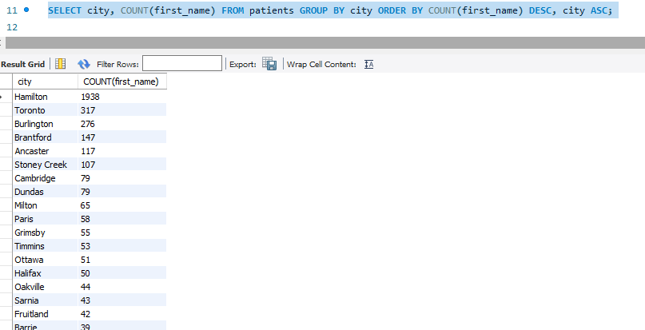

1. **Show first name, last name and role of every person that is either patient**

**or doctor. The roles are either "Patient" or "Doctor"**

**Ans.** SELECT 'Patient' AS Role, first_name, last_name FROM patients UNION SELECT 'Doctor', first_name, last_name FROM doctors;

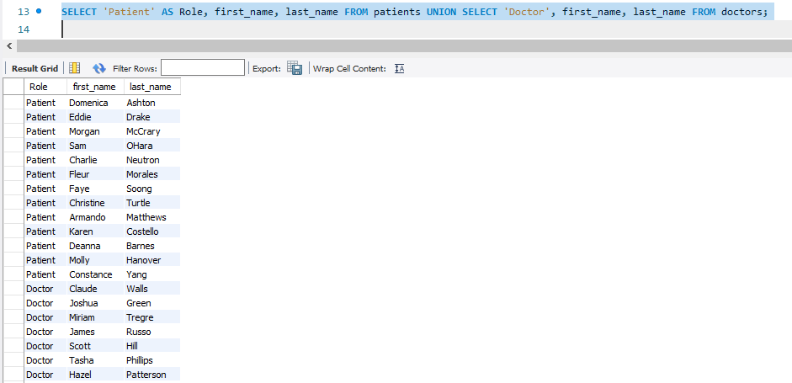

1. **Show all allergies ordered by popularity. Remove NULL values from the**

**query.**

**Ans**. SELECT DISTINCT allergies FROM patients WHERE allergies IS NOT NULL GROUP BY allergies ORDER BY COUNT(patient_id) DESC**;**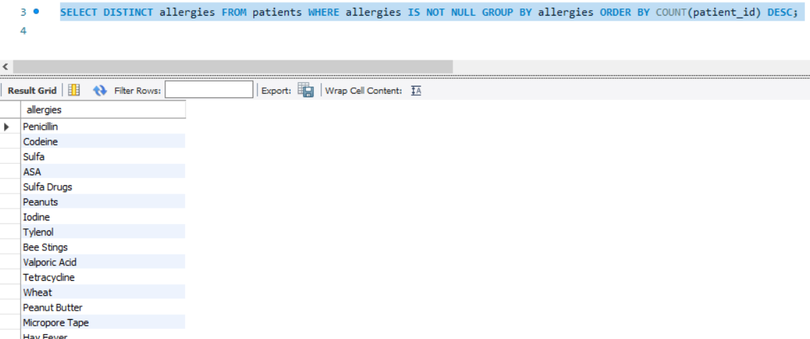

1. **Show all patient's first_name, last_name, and birth_date who were born in**

**the 1970s decade. Sort the list starting from the earliest birth_date.**

**Ans.** SELECT first_name, last_name, birth_date FROM patients WHERE YEAR(birth_date) >= 1970 AND YEAR(birth_date)<1980 ORDER BY birth_date;

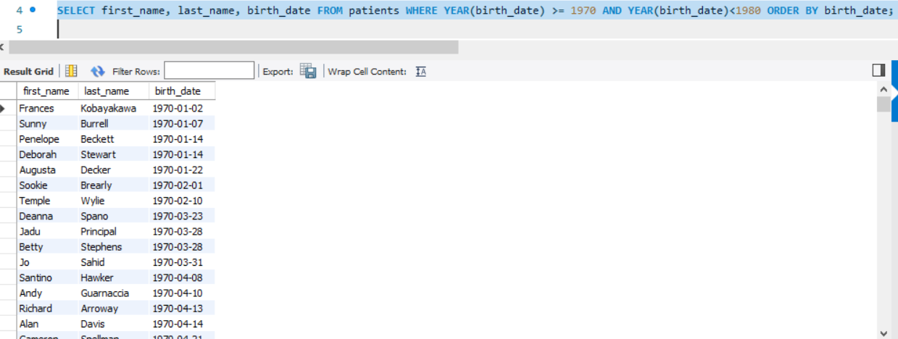

1. **We want to display each patient's full name in a single column. Their last_name in all upper letters must appear first, then first_name in all lowercase letters. Separate the last_name and first_name with a comma. Order thelist by the first_name in descending order EX: SMITH,jane**

**Ans.** SELECT CONCAT(UPPER(last_name),",", LOWER(first_name)) AS full_name FROM patients ORDER BY first_name DESC LIMIT 5000;



1. **Show the province_id(s), sum of height; where the total sum of its patient's**

**height is greater than or equal to 7,000.**

**Ans.** SELECT province_id, SUM(height) AS totalheight FROM patients GROUP BY province_id HAVING SUM(height)>=7000;

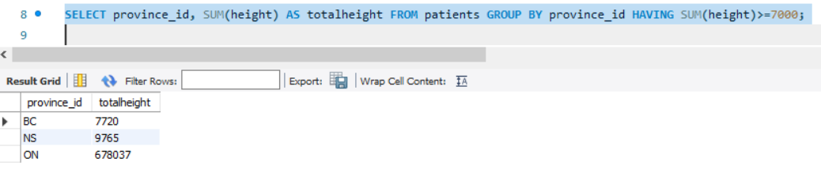

1. **Show the difference between the largest weight and smallest weight for**

**patients with the last name 'Maroni'**

**Ans.** SELECT MAX(weight)-MIN(weight) FROM patients WHERE last_name='Maroni';

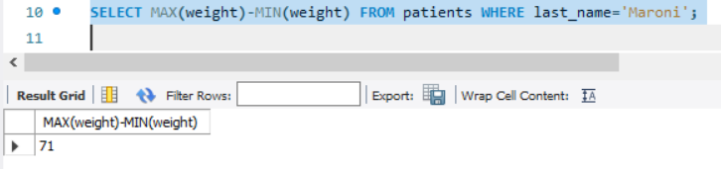

1. **Show all of the days of the month (1-31) and how many admission_dates**

**occurred on that day. Sort by the day with most admissions to least**

**admissions.**

**Ans.** SELECT DAY(admission_date), COUNT(admission_date) FROM admissions GROUP BY DAY(admission_date) ORDER BY COUNT(admission_date) DESC;

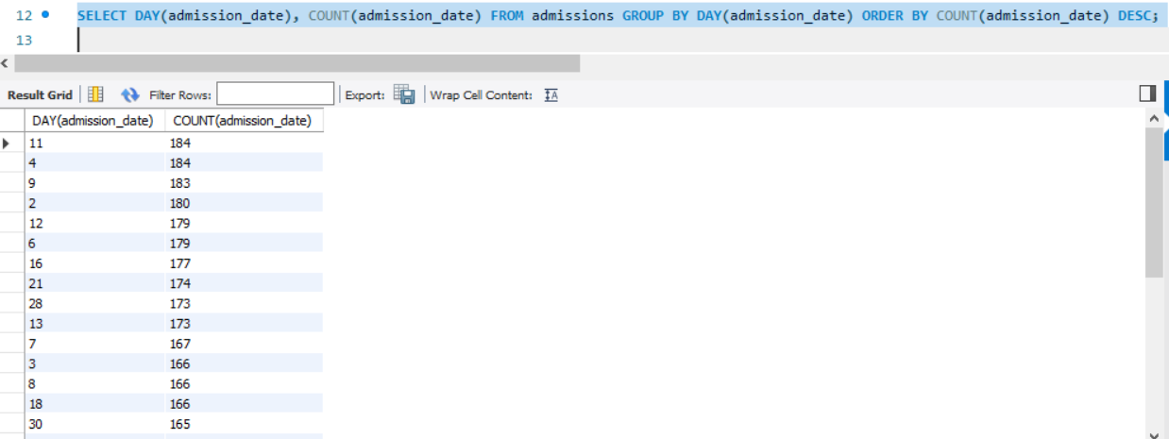

1. **Show all of the patients grouped into weight groups. Show the total**

**number of patients in each weight group. Order the list by the weight group**

**descending. e.g. if they weigh 100 to 109 they are placed in the 100 weight**

**group, 110-119 = 110 weight group, etc.**

**Ans.** SELECT CASE

WHEN weight BETWEEN 0 AND 25 THEN '0-25'

WHEN weight BETWEEN 26 AND 50 THEN '26-50'

WHEN weight BETWEEN 51 AND 75 THEN '51-75'

WHEN weight BETWEEN 76 AND 100 THEN '76-100'

WHEN weight BETWEEN 100 AND 25 THEN '100-125'

ELSE '126-150'

END AS WeightRange,

COUNT(*) AS Num_patients

FROM patients

GROUP BY WeightRange

ORDER BY WeightRange;

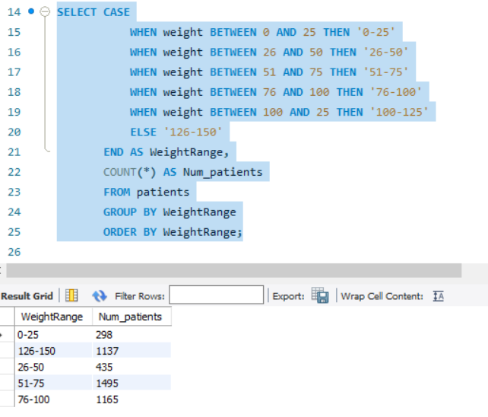

1. **Show patient_id, weight, height, isObese from the patients table. Display**

**isObese as a boolean 0 or 1. Obese is defined as weight(kg)/(height(m).**

**Weight is in units kg. Height is in units cm.**

**Ans.** SELECT patient_id, weight, height,

CASE

WHEN weight/POWER((height/100), 2) > 30 THEN '1'

ELSE '0'

END AS isObese

FROM patients;

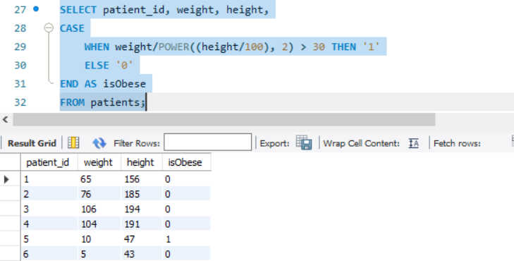

1. **Show patient_id, first_name, last_name, and attending doctor's specialty.**

**Show only the patients who has a diagnosis as 'Epilepsy' and the doctor's first**

**name is 'Lisa'. Check patients, admissions, and doctors tables for required**

**information.**

**Ans.** SELECT patients.patient_id, patients.first_name, patients.last_name, doctors.specialty FROM ((admissions INNER JOIN patients ON admissions.patient_id = patients.patient_id) INNER JOIN doctors ON admissions.attending_doctor_id = doctors.doctor_id) WHERE diagnosis='Epilepsy' AND doctors.first_name='Lisa';

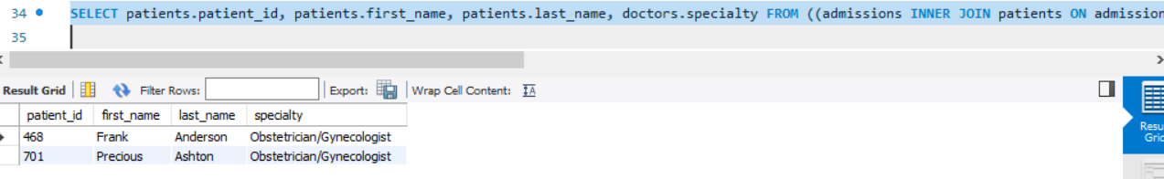

1. **All patients who have gone through admissions, can see their medical**

**documents on our site. Those patients are given a temporary password after**

**their first admission. Show the patient_id and temp_password.**

**Ans.** SELECT patient_id, CONCAT(patient_id, LENGTH(last_name), YEAR(birth_date)) AS temp_password FROM patients;

